AiVB

Algorithm and Data Patterns
Final Exam

Student Name: Daniel Schenker

Student Number: 212395

Good luck
Soheil

- Considering the fact that you have 8 directions( South, North, East, West, North East, North West, South East and South West) and the direction table build the graph that’s representing this direction table.(10 Marks)

Direction | North | South | East | West | South  East | North East | South West | North West
0 |  |  |  | 1
1 |  | 3 | 0 |  | 4 |  | 2
2 |  |  |  |  |  | 1 | 5
3 | 1 | 7 | 4
4 |  | 8 |  | 3 |  |  |  | 1
5 |  |  |  |  | 6 | 2
6 |  | 9 | 7 |  |  |  |  | 5
7 | 3 |  |  | 6 |  | 8 | 9
8 | 4 |  |  |  |  |  | 7
9 | 6 |  |  |  |  | 7

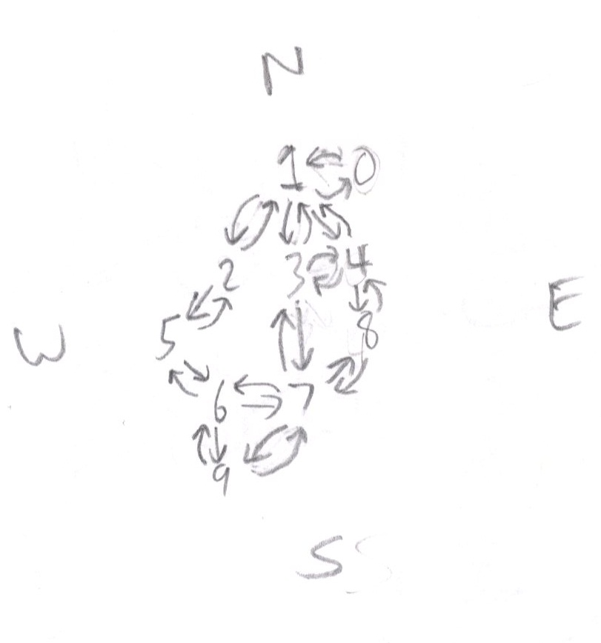

- Using an array for nodes and linked list for arcs represent this graph as a general purpose unidirectional graph (10 marks)

1
2
5
4
3
6
A
B
C
D
E
F
G
 | A | B | C | D | E | F | G
1 | 2 | 4
2 |  |  | 3
3
4 |  |  |  | 3
5 |  |  |  |  |  |  | 3
6 |  |  |  |  | 4 | 5

- Considering the pattern 1101 and using an algorithm similar to R250 for only 4 bits generate 10 random numbers based on the formula Bit 5 = Bit 1 Xor Bit 4 .(5 marks)

1101 original num = 8+4+1 = 13
01101 5th bit = 1 XOR 1 = 0
0110 1st new num = 4+2 = 6
00110 5th bit = 0 XOR 0 = 0
0011 2nd new num = 2+1 = 3
10011 5th bit = 0 XOR 1 = 1
1001 3rd new num = 8+1 = 9
01001 5th bit = 1 XOR 1 = 0
0100 4th new num = 4
00100 5th bit = 0 XOR 0 = 0
0010 5th new num = 2
00010 5th bit = 0 XOR 0 = 0
0001 6th new num = 1
10001 5th bit = 0 XOR 1 = 1
1000 7th new num = 8
01000 5th bit = 1 XOR 0 = 1
0100 8th new num = 4
00100 5th bit = 0 XOR 0 = 0
0010 9th new num = 2
00010 5th bit = 0 XOR 0 = 0
0001 10th new num = 1

- Create the frequency table and Huffman tree for the line below (15 Marks)

“Ho Ho Ho Merry Christmas by Santa Clause”

Frequency Table (broken on to two lines due to space issues)
H | o | Sp | M | e | r | y | C | h | i
3 | 3 | 7 | 1 | 2 | 3 | 2 | 2 | 1 | 1

s | t | m | a | b | S | n | t | l | u
2 | 1 | 1 | 3 | 1 | 1 | 1 | 2 | 1 | 1

Sorted Frequency Table from least to most used character
M | h | i | t | m | b | S | n | l | u
1 | 1 | 1 | 1 | 1 | 1 | 1 | 1 | 1 | 1

e | y | C | s | t | H | o | r | a | Sp
2 | 2 | 2 | 2 | 2 | 3 | 3 | 3 | 3 | 7

Combining into trees (part 1)
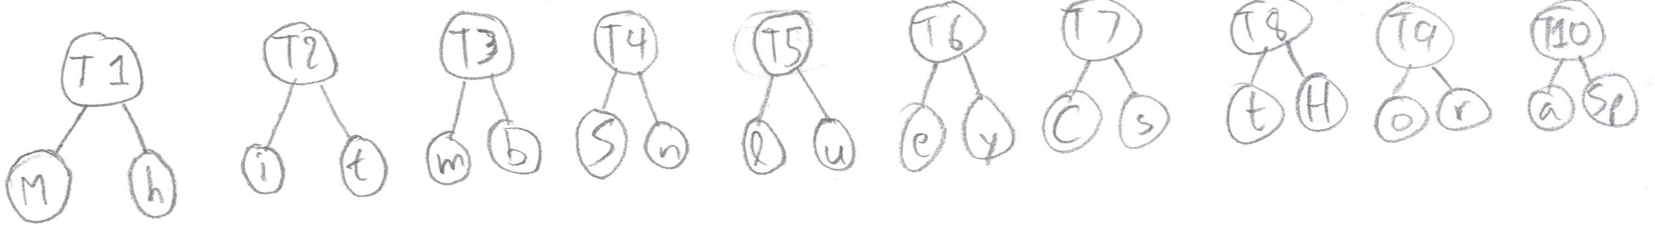
T1 | T2 | T3 | T4 | T5 | T6 | T7 | T8 | T9 | T10
2 | 2 | 2 | 2 | 2 | 4 | 4 | 5 | 6 | 10
Combining into trees (part 2)
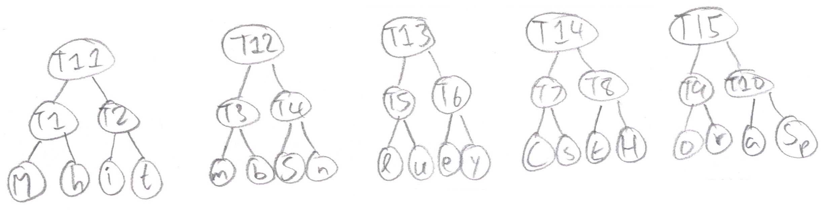
T11 | T12 | T13 | T14 | T15
4 | 4 | 6 | 9 | 16
Combining into trees (part 3)
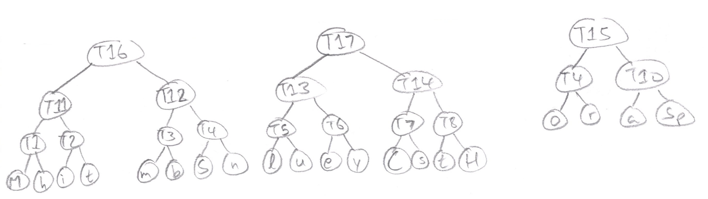
T16 | T17 | T15
8 | 15 | 16
Combining into trees (part 4)
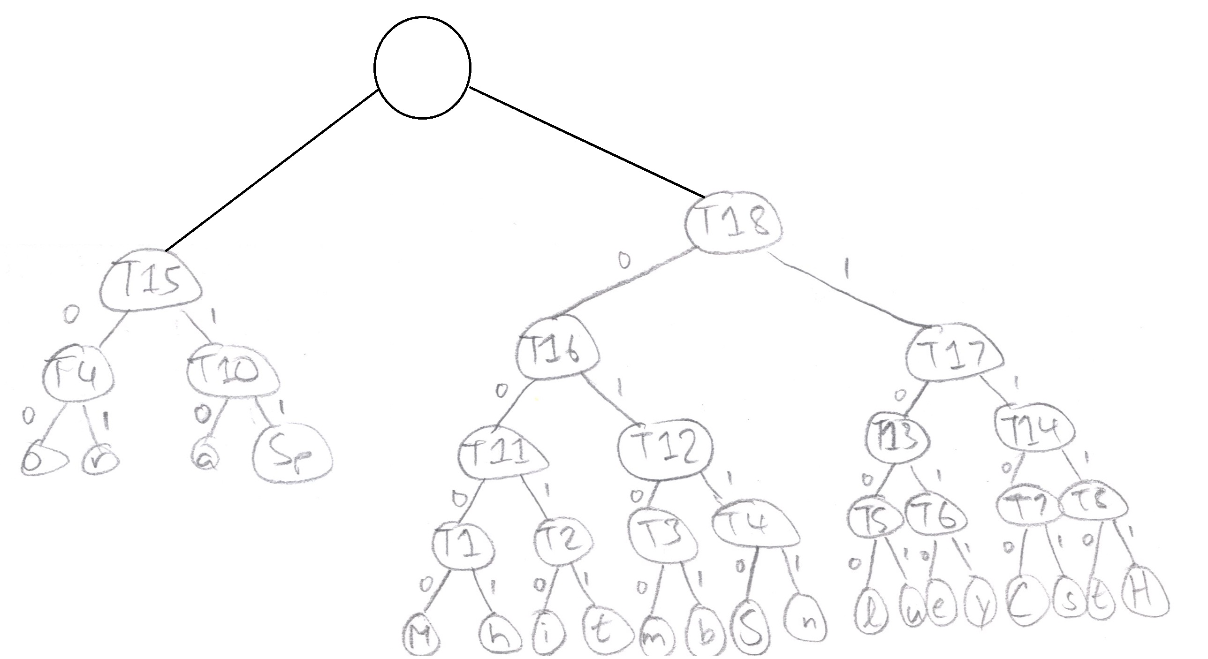
T15 | T18
16 | 23

- Using RLE compression method compress the sentence “Hmmmmmmm, Did you say Hickory, Dickory Duck?”(5 marks)

Let ~ represent a space

1H7m1,1~1D1i1d1~1y1o1u1~1s1a1y1~1H1i1c1k1o1r1y1,1~1D1i1c1k1o1r1y1~1D1u1c1k1?

- Consider that you have an array of integers A = {44, 75, 23, 43, 55, 12, 64, 77, 33}, Using Quick sort Algorithm Show the intermediate stage of the array until it is sorted.(10 marks)

Pick center: 55
Split numbers (smaller on left, bigger on right) until each node of the tree has only 1 value
55
44 23 43 12 75 64 77
Repeat using recursion
55
23 64
12 43 44 75 77
Repeat using recursion
55
23 64
12 43 75
44 77
The tree can now be read to display the array in its sorted state
12, 23, 43, 44, 55, 64, 75, 77

- Consider the following items with their corresponding keys.(10 marks )

Key | 0.513 | 0.175 | 0.308 | 0.410 | 0.233 | 0.782 | 0.644
Item | A | M | T | Z | Q | V | S

Now consider that you have only 4 rows to create your hash table. Using modular hash algorithm, find your hash function and implement a collision handled hash table.

First I see that the range of values given is between 0 and 1, so this is the hash table that I will use that is comprised of 4 rows, to store the data

Using the modular has function I studied previously: f(k) = k mod r
Where k is the key, and r is the amount of rows in the has table

If a collision occurs, I will use chaining, by simply creating a list that must be traversed one element at a time to find the collision handled value.

Now to insert the data into the table in the correct position
A
f(0.513) = (0.513) mod (4) = 0.513
since 0.5 <= 0.513 < 0.75, therefore A = 0.5

Repeat for all data
0 | M | Q
0.25 | T | Z
0.5 | A | S
0.75 | V

- 15. Consider the following tree, First Change it to binary search tree and then traverse it in PreOrder, and Inorder and PostOrder and write the results. (10 Marks)

16
41
10
14
7
92
3
2
8
1

Convert to binary search tree:

14
7
41
2
10
16
92
1
3
8

PreOrder: 1, 3, 2, 10, 8, 7, 16, 92, 41, 16
InOrder: 1, 2, 3, 7, 8, 10, 14, 16, 41, 92
PostOrder: 92, 16, 41, 8, 10, 3, 1, 2, 7, 14

Part 2, Implementation (25 marks)

In order to deal with the problems with dangling pointers you decide to create a class that serves as a pointer. You will call this class a smart pointer and use object oriented facilities to initialize and destroy the pointer. Remember that smart pointer is really a proxy. Create another class called actualdata that only holds a string as its member, then create a driver program that uses a smart pointer (that you made) to point to objects made of actual data.

